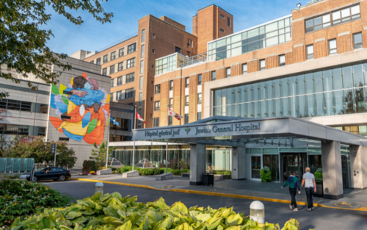

Gynecologic Oncologist

Jewish General Hospital

McGill University

The Jewish General Hospital, a McGill University affiliated institution, is seeking a full-time Gynecologic Oncologist to join the team. The applicant would join a Team of four Gynecologic Oncologists who are contributing to innovation by participating in clinical trials focused on targeted therapies, performing the majority of the surgeries by using the robotic platform, and supporting a large biobank as well as basic and translational research in the Gynecologic Oncology Laboratory at the Lady Davis Institute. The Team works closely with medical and radiation oncology, pathology, palliative care and genetics. The Team is looking for a new collaborative team member who is passionate about innovation and is dedicated to providing and advancing the highest quality of care.

The successful applicant will:

* Provide comprehensive gynecologic oncology care as part of a multidisciplinary team including surgery, inpatient care, clinics, chemotherapy, and colposcopy;
* Be engaged in innovative research and the education of medical learners of all levels (fellows, residents, students);
* Be eligible for clinical academic appointment at McGill University, Department of Obstetrics and Gynecology, and Oncology.

The Jewish General Hospital is well renowned for providing cutting edge cancer care (Segal Cancer Centre). The Clinical Trials Unit has the infrastructure to support phase I, II and III clinical trials. Innovation, development and evaluation of robotic surgery represents the core of the surgical mission in the division. Candidates should have an interest in pursuing innovation, teaching/education and research within their professional scope.

Applicants must be certified (or eligible for certification) by the Royal College of Physicians and Surgeons of Canada in the subspecialty of Gynecologic Oncology and must be licenced or eligible for licensure by the Collège des médecins du Québec. Gynecologic Oncologists in our Division will be compensated on a fee-for-service basis. Non-French speaking candidates will need to pass a French language proficiency exam.

McGill University commits to achieving inclusive excellence through continually championing equity, diversity, inclusion, and accessibility. The university encourages applications from Indigenous persons, persons of Black/African descent, and members of other racialized groups, persons with disabilities, women, and persons identifying as members of 2SLGBTQIA+ communities, and all candidates who would contribute to the diversity of our community. All qualified candidates are encouraged to apply; however Canadians and permanent residents will be given priority.

Qualified candidates should submit a letter of interest, curriculum vitae, and the names of three (3) references to:

Walter H. Gotlieb, MD, PhD, Division Head

Jewish General Hospital

walter.gotlieb@mcgill.ca